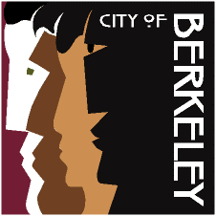

BERKELEY RIDES FOR SENIORS
& THE DISABLED

HIGH MEDICAL NEED PROGRAM

Health, Housing &
Community Services
Aging Services Division

About the Program:

Berkeley Rides for Seniors & the Disabled (BRSD) provides no cost supplemental transportation assistance for City of Berkeley seniors and people with disabilities.

The High Medical Need Program (HMNP) is available to those already registered as a BRSD participant and have frequent medically related appointments. Approved applicants will receive additional taxi script or wheelchair van vouchers for transportation to and from medically related appointments.

HMNP Program Requirements:

- Must be a registered participant with BRSD to be eligible to apply for the High Medical Need Program. *See info below to apply to BRSD program*

- Must have a medically related appointment at least twice per month.

- Medically related appointments include doctor visits, physical therapy or other related rehabilitation therapies, dialysis, radiation and chemotherapy treatment.

- Must have a Physician’s Certification signed by your physician verifying your medical visits.

BRSD Eligibility:

- You are a Berkeley resident AND age 70 or over; OR
- Anyone who is East-Bay Paratransit certified, of any age

Where can I get a BRSD application?

You can call (510) 981-7269 and request an application or go to our website at https://berkeleyca.gov/community-recreation/seniors/transportation-services and download an application. Once you have completed the application and attached all requested documentation, please mail all of your materials to:

Berkeley Rides for Seniors the Disabled
1901 Hearst Avenue, Berkeley, CA 94709

Contact Information: Please call (510) 981-7269

