MINDFULNESS THROUGH THE AGES
a
y
s
T
o
g
e
t
h
e
r
M
o
r
e
G
o
o
d
D

Mental Health Awareness Month Event

Scan or Click Here to Register
HTTPS://SHORTURL.AT/AXK0C


Activities for all ages Resource Tables


Mindful Breakout Sessions Food, Prizes and Entertainment

FRIDAY, MAY 29, 2026
4:00-7:30
West BerkeleyFamily Wellness Center 1900 Sixth St, Berkeley, CA 94710





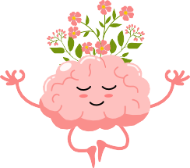



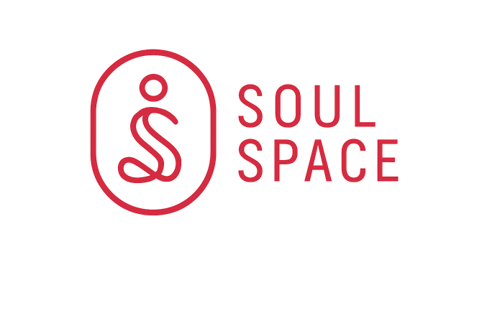


CONTACT US
For More Information (510) 981.7624

