Take Action for Community Mental Health Wellness
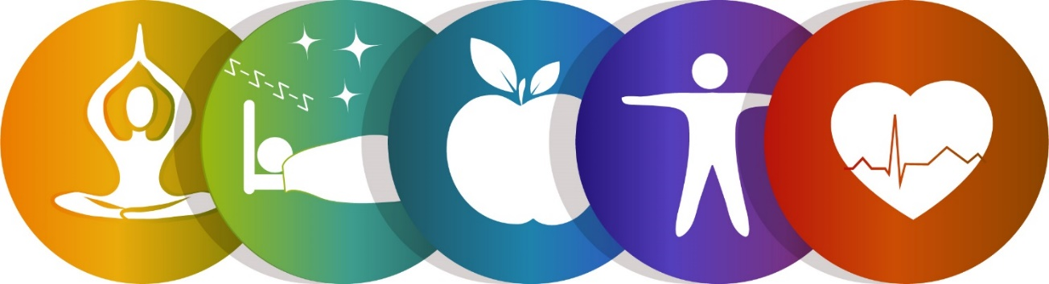

Ending Mental Health Stigma and Discrimination

Join us at this fun and interactive event:

Relaxation &
Stress Release Tips
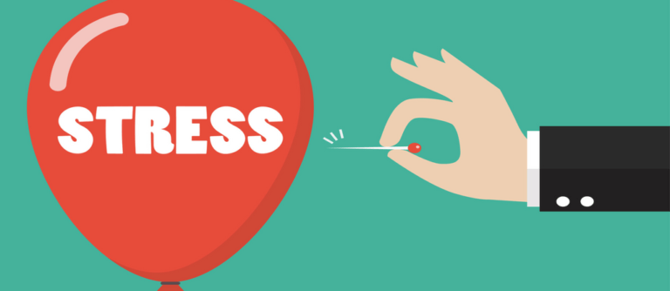
Energizing Movement
Raffle Prizes


Magical fun & laughter
Awards
- Music 

Healthy Eating Tips

Free Zoom/Call-In Community Event!
When: Wednesday, May 25, 2022
Time: 5:30 - 7:30 P.M.
Zoom Registration Link:
https://us06web.zoom.us/webinar/register/WN_GoUKdRC5RuyDCVx8nwHfsw

Telephone option: Dial: US: +1 669 900 6833 Webinar ID: 816 4887 6503
For additional information contact: (510) 981-5290

